Your Ideas • Your Vision

**Day Services Vision**

Welcome to the Future

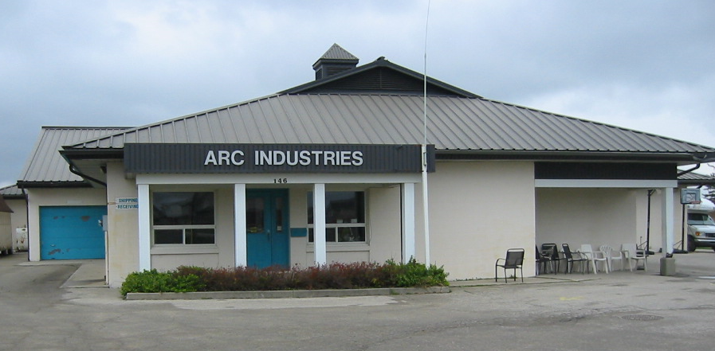

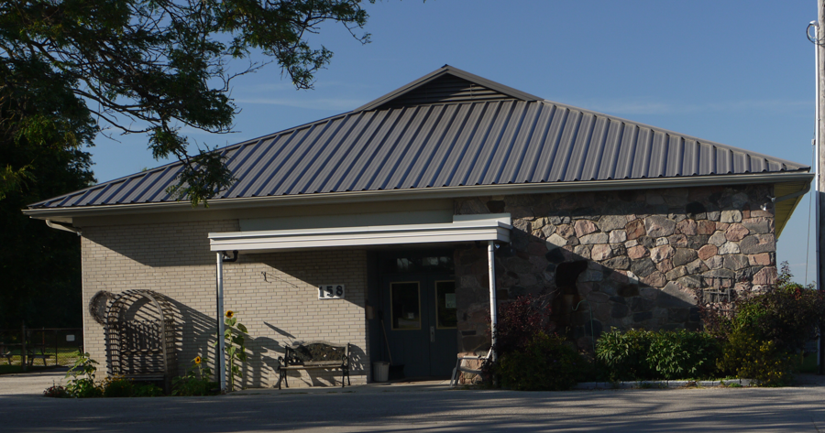

***Why a new vision for EDCL’s Day Services?***

1. *Make Day Services even better;*
2. *Provide state-of-the-art facilities; and*
3. *Be proactive in responding to possible government funding changes.*

*Once the new vision is in place, EDCL will be a leader in offering the activities people want, where and when they want them.*

Prepared with assistance from

CMCS Consulting Services

Draft 2 – March 2023

**Welcome to the Future**

The world is changing.

Soon, it’s expected that people with intellectual challenges will receive their own money from the Ontario government to pay for the activities they want to be involved in during the day, evenings and weekends.

When that happens, Elmira District Community Living (EDCL) will be a leader in offering the activities they want, where they want them. Some will be available in a new or renovated building.

Other activities will take advantage of community resources, mostly in Elmira but also in the surrounding area.

The Day Services building of the future will accommodate a wide range of activities. Some participants will spend most or all of their day there and be supported in a safe, engaging environment. Some will choose to come and go, depending on their schedules and where their activities are located. All will have a place to socialize and be with their friends.

Other community members will be able to attend activities sponsored by Day Services. They will also be able to use its facilities during the evening and on weekends.



**Introduction**

**Why A New Vision For Day Services**

Elmira District Community Living wants each person it serves to have the best life possible, which means providing the best supports possible. That is the motivation for everything it does, including planning for the future.

Elmira District Community Living began developing a new vision for Day Services a number of years ago. That undertaking was an important component of its 2018 strategic plan. Unfortunately, visioning was interrupted by the pandemic. Now that EDCL is able to shift its focus, it can proceed with its commitment to reimagining Day Services.

The need for planning has been made more pressing by the age of the two Day Services buildings and by a major policy initiative from the funder of day supports, Ontario’s Ministry of Children, Community and Social Services. That initiative is titled “Journey to Belonging”.

Journey to Belonging “focuses on people and how they can belong in their communities and live meaningful lives” and is based on the following principles:

* **People receive support based on their needs**: Greater equity through individualized funding and budgets tied to people’s assessed needs.
* **Services build on the strengths of people and supports provided by families, support networks and communities:** Supports complement services available in the community and are culturally appropriate.
* **Supports are person-directed and flexible:** People have more control over directing and managing their funding and supports.
* **Supports are proactive and responsive to people’s changing needs across the course of their lives:** Greater focus on early intervention and prevention for people, with supports that are better integrated with other sectors.
* **Services are driven by evidence, outcomes and continuous improvement:** More emphasis on outcomes and quality services that are responsive to feedback from people using them.
* **Services and supports promote health, well-being and safety:** Services promote positive health and wellness outcomes and a high quality and meaningful life experience. Supports help address systemic barriers (for example, discrimination, racism, ableism) that prevent people from accessing supports and fully participating in their communities.
* **System is sustainable:** Improving the ability of developmental services to help people now and into the future.

As part of the policy contained in Journey to Belonging, the Ontario government is expected to change its funding model for day services. That model will be an expanded Passport-style program in which participants and their families receive an individualized amount to spend as they see fit. If this happens, EDCL will then be in competition with other service providers in offering day supports.

In summary, the motivation for a new vision is three-fold: make Day Services even better; provide state-of-the-art facilities; and be proactive in responding to government funding changes.

**How Was The New Vision Created?**

The starting point and the heart of creating a vision for Day Services was the input offered by everyone with an interest in its future. This includes the people supported in Day Services programs, their families, EDCL employees and its Board of Directors, as well as those involved with its supportive housing corporation, Elmira Developmental Support Corporation (EDSC).

This input was obtained using surveys in 2021 and 2022, along with focus groups and more surveys in early 2023. The 2021 survey involved people supported in Day Services, as well as those who might in the future. The 2022 survey was for Day Services staff. The focus groups in 2023 were for people supported in Day Services, Day Services staff, families of people involved in Day Services and the EDCL management team. The 2023 survey was for families who couldn’t attend the focus group and for supportive housing staff.

The questions asked in the surveys and the focus groups included what activities should be provided in Day Services; the time of day and days of week for scheduling them; whether Elmira District Community Living should continue to have a Day Services building and if so, whether the activities held there should also be open to community members; and whether the building should be made available to other groups in the evenings and on weekends.

Help in gathering the information was provided by Tom Little and Nancy Collins of CMCS Consulting Services. Over the years, they have worked with EDCL many times on training and on planning. They reviewed the findings of the 2021 and 2022 surveys. They facilitated focus groups of people supported in Life Skills and Avenues, of the staff from those two venues, of families and of the management team. They also obtained survey input from supportive housing staff, and from families unable to attend the focus group.

They then consolidated that information and shared it with management members Cheryl Peterson, Sarah Cadeau, Christine Clarke and Donna Fulcher. Cheryl, Sarah, Christine and Donna then used the ideas provided by all the stakeholders to give final shape to the vision.

This vision belongs to everyone who contributed their ideas.

It is your vision.

**Day Services: Your New Vision**

**What You Said About Day Services in the Future**

*I would like to:*

* *Read books about animals*
* *Go swimming at the rec centre*
* *Go for coffees at Tim’s/McDonalds*
* *Spend time with friends; go to Burger King; go bowling more*
* *Watch videos online of Tom & Jerry*
* *Get a job or volunteer position at the library*
* *Go to Conestoga Mall in Kitchener to have lunch and shop; look around;*
* *Do more arts and crafts in the community in person*
* *See musicals*
* *Do wordsearch books with friends*
* *Go to Yoga class*
* *Go for a drive again out in the country*
* *Go to church for mass and find out what other activities they might have like church dinners*
* *Would like to go to car racing in Grand Bend; St. Thomas; Cayuga*
* *Would like to have my own library card so I could take out my own books*

**Focus group input from people supported by EDCL**

*The purpose of a building would be to have a place where people can gather and socialize, again a space away from where they live. Ideally a place where community is comfortable to join us and also a hub where someone can be picked up to go out into the community. The building where potentially we could offer a space for group activities, volunteers, very similar to what we have offered in the past but in a new building.*

*Before Covid, a couple of years ago, we had quite a few volunteers come into Avenues, as well as taking the participants out into the Community to the Recreation Centre, biking, coffee, book club, etc. This was so rewarding for both the participants and volunteers. Avenues was a flurry of activity with community coming into Avenues to lead fitness, crafts, drumming and music classes, etc. We also joined community groups; such as aqua, fitness, St. Jacobs seniors' classes, church luncheons, breakfast clubs, etc.*

**Input from 2022 staff survey**

*There are so many people with different needs. Keeping everyone active with some sort of activity is essential to their ongoing development. Exercise is of paramount importance for their wellbeing.*

*Work is important.*

*Ideally, we would like the day to be comprised of some work, some volunteering, some activities.*

**Focus group input from families of people supported by EDCL**

*The ideal would be multiple small groups that are in/out through the day. Participants might move between groups depending on the activity. Participants would be the ones determining the activities being done.*

**Focus group input from Day Services staff**

**Activities**

A wide range of activities will be made available to participants, including by adding to those currently scheduled at the Day Services building or elsewhere in the community:

* Exercise and fitness
* **A picture containing text, sky, outdoor, road

  Description automatically generated**Daily living skills (e.g. cooking, money, writing, hygiene)
* Arts and crafts
* Music (listening, playing instruments, singing)
* Computer/technology use
* Reading
* Sensory stimulation (e.g. Snoezelen)
* Movies
* Education (e.g. job readiness, resume building, safety and awareness)

Some activities will be available only in the broader community, such as:

* Going for coffee and meals
* Attending activities sponsored by community groups (e.g. breakfast clubs, church luncheons)
* Attending special events including live shows, the Market, African Lion Safari, the beach and hikes
* Volunteering

Some activities will be available virtually.

Group sizes will vary to take account of the fact that some participants prefer activities that involve only a few people.

Activities will be scheduled by season and participants will decide on their individual schedules using My Community Hub, as at present. Once registered, participants can print off their monthly calendar and then supplement with more spontaneous activity as they choose and as available.

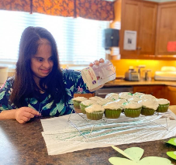

In a related undertaking, Day Services will spearhead an initiative in collaboration with other local organizations, including the Mennonite community, focused on participants who are asking for activities that include work.

The program will involve life skills, education, work-related training, employment and volunteering. Consideration will be given to developing social enterprises to provide employment for the people involved.

**Next steps**

1. Continue to add to the range of activities offered.
2. Begin the initiative with other organizations for people wanting work activity.

**Participants**

Elmira District Community Living will continue to make Day Services available to the eighty-three people it currently supports, both those taking advantage of its various housing options and those living in the larger community.

Of those who access Day Services activities, about half live in EDCL housing options. For the most part, they use their homes as the base for their day activities. They are expected to continue to do so, while accessing Day Services as they wish. The other half will constitute the core group engaging in Day Services activities going forward.

Planning for the future will include making provision for additional participants as they complete their education or move into the Elmira area. All those involved now or requesting support in the future will have access to the range of activities offered by Day Services, either in its new building, on-line or in other community locales.

**Next steps**

1. Further develop Elmira District Community Living’s capacity to market its Day Services program so it can add to the number of participants as demand and resources allow and in anticipation of individualized funding.
2. As noted above, begin the initiative with other organizations for people wanting more work-related activities.

**Days Of The Week / Hours**

Most participants will access Day Services activities five days a week from 9 a.m. to 3 p.m., reflecting their preference, as indicated in the two surveys conducted in 2021 and early in 2023.

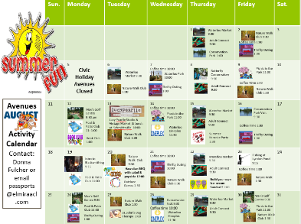

There will be some people whose interests mean the activities may take place in the evenings and on the weekends. Day Services will work to develop the capacity to serve this group as well.

While over eighty people will be served in total, estimated attendance at the Day Services building each day will be in the low 40s, since about half are supported out of their homes. Some participants will come and go, depending on their choice of activities. If demand for Day Services increases over time, the building will be designed so it can accommodate an increased number.

**Building**

Once the Board of Directors of EDCL has explored all options, it will decide whether there will be a “new” Day Services building (constructed or purchased) or whether the Avenues building will be renovated. Whatever the outcome, EDCL will ensure it is a state-of-the-art facility.

This new Day Services building will accommodate a range of activities. It will also be the jumping off point for people engaging in activities located elsewhere in Elmira and area. Finally, it will be a place where participants can come and socialize with their friends.

The new building will also accommodate more participants, including those with individualized funding who come to Elmira District Community Living for support. It will be large enough to accommodate other community members wanting to participate in activities offered by Day Services and held within the building.

Depending on further consultation with other community groups, the new building may contain amenities like a commercial kitchen and large meeting/eating area that could be used by other community groups.

The key benefit of making the building available to community groups is fostering the engagement of the broader community in EDCL and the people it supports. This will involve careful investigation on Elmira District Community Living’s part, including zoning, demand for such space and the responsibilities of EDCL in managing the use of the building by third parties.

**Next steps**

1. Continue to investigate Elmira District Community Living’s capacity to undertake a building project in conjunction with determining the future of its Life Skills property, which will no longer be needed. Involve the supportive housing corporation, Elmira Developmental Support Corporation, as appropriate.

**Other Locales Outside Elmira**

Of the people living with their families who access Day Services, their current numbers and home communities are as follows:

4 – Elmira, Linwood

3 - Wallenstein

2 – St. Jacobs

1 – each in St. Clements, Conestoga, Breslau, Waterloo, Millbank, Wellesley and Drayton

Day Services will investigate the possibility of facilitating activities in one or more of these communities, Linwood or Wellesley for example, which have recreation centres. This could happen once a week, once a month or on a periodic basis, depending on demand.

**Next steps**

1. Begin investigation of the use of alternative sites and proceed based on the findings.

**Staffing / Volunteers**

As long as government funding continues as at present, staffing will be comprised of ten employees plus the manager. Unfortunately, the current number of staff puts limits on EDCL’s capacity to facilitate the community involvement of Day Services participants.

To help address the situation, Day Services will reinstitute its Passport staffing, now that the pandemic is coming to an end. Passport staff will support people to engage in their chosen activities in the larger community, individually or in small groups. More Passport staff will be added if more people with Passport funding come to Elmira District Community Living for support.

Action is being taken to fund and hire a Volunteer / Community Co-ordinator to increase the existing pool of direct support volunteers, to search out volunteer opportunities for people supported and to develop partnerships and create community awareness.

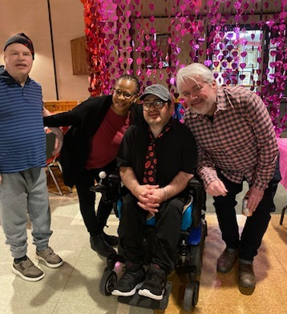

In preparation for individualized funding, EDCL will focus more attention on helping all staff further develop their skills related to being ambassadors and community connectors. It will also recruit people with those skills when additional staff are being hired or vacancies occur.

**Next Steps**

1. Reinstate the Passport program.
2. Continue to seek funding for a Volunteer / Community Co-ordinator position, then proceed with hiring and implement the volunteer program.
3. Create and implement a development program for staff in acting as an ambassador and community connector.
4. Continue to advocate for funding for additional staff.

**Transportation**

Transportation is always an issue in smaller communities, and Elmira is no exception. Day services shares vehicles with EDCL’s housing locations. While helpful, this is not enough to facilitate all the community activities participants are requesting. Going forward, Day Services will work towards adding one or more vehicles dedicated to providing more community activity options for the people it supports.

**Next Steps**

1. Work towards adding one or more vehicles dedicated to providing more community activity options for the people it supports.
2. Continue to advocate for and collaborate with community transportation services and enhance its partnership with local parallel transit organization and Elmira Development Support Corporation.
3. Seek grant and other funding opportunities that will increase transportation capacity for Day Services participants, staff and the community at large.

**Conclusion**

The reasons behind the creation of a new vision for Day Services include Elmira District Community Living’s commitment to excellence, its strategic plan, the age of its current buildings and a new policy initiative from its funder.

EDCL envisions a Day Services of the future that includes a new building, a wider range of activities and more community engagement involving the people it supports, other community members and local organizations. The program will also accommodate more participants as demand and resources allow.

The vision for Day Services as set out above will be forwarded to EDCL’s Board of Directors for its consideration. Once approved, the management team will spearhead its implementation, engaging the other stakeholders in the process.

In the end, the vision is the product of the ideas of all those connected to Day Services and Elmira District Community Living: the people it serves, their families, employees and the Board of Directors.

This is your vision!