**`**

**Strategic Plan *Refresh***

**2023-2024**

***In Defence of Community***



***Maintaining our grassroots connections***

**Developed with assistance from CMCS Consulting Services, Oshawa**

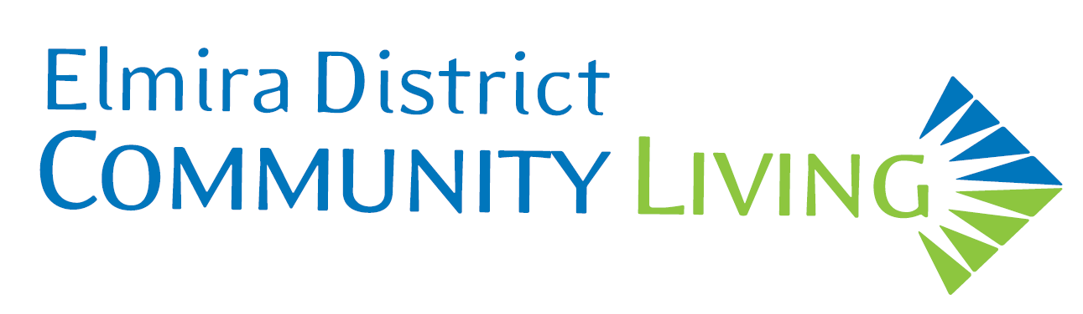

1. **About the Refreshed Plan**

In 2018, Elmira District Community Living (EDCL) developed **In Defence of Community**, its 2018-23 Strategic plan. Unfortunately, the pandemic interceded, and the organization’s focus turned to safety while maintaining day-to-day operations.

The review was completed by Executive Director Cheryl Peterson with input from Services Director Sarah Cadeau, Director of Finance Christine Clarke and Director of Human Resources Nicole McEwan. Providing assistance was Tom Little of CMCS Consulting Services. Tom and his colleague Nancy Collins facilitated the development of the 2018 plan.

Since the refreshed plan covered only one year, the actions were adjusted and changed so they could be completed within a twelve-month timeframe. In addition, the fourth strategic direction from the 2018 plan, *Maximize EDCL’s Use of Technology*, was absorbed into the third direction, *Address Resource Issues***.**

The refreshed plan continues to take account of the policy contained in the document titled “Journey to Belonging”, developed by EDCL’s funder, Ontario’s Ministry of Children, Community and Social Services. Journey to Belonging is in its early stages of implementation. The focus is on choice, on empowerment and on individualized supports and individualized funding. EDCL will monitor this policy initiative and adjust the organization’s strategies accordingly as implementation proceeds.

EDCL will continue to work to maintain its grassroots connections and responsiveness to families and the community; it will continue to strive for ongoing improvements in service delivery and in the quality of life enjoyed by people with intellectual disabilities in Elmira and District and it will keep exploring innovative and creative ways to enhance service capacity, both on its own and through meaningful collaborations with like-minded organizations.

1. **Strategic Directions**

The plan for 2023-24 includes four directions:

* **Enhance the Quality of Life of People with Intellectual Disabilities in Elmira and District**
* **Further Empower and Engage the People EDCL Supports**
* **Address Resource Issues**
* **Enhance the Governance Capacity of the Board of Directors**

**Maintaining Our Grassroots Connections**

Each direction contains one or more goals. Most goals contain one or more key actions. Both the goals and key actions are intended to explain how the organization will move in each direction and to provide assurance that the direction will be achieved.

Direction 1 – Services

**Enhance the Quality of Life of People with Intellectual Disabilities in Elmira and District.**

*An even better life centred on connections and community involvement.*

Goal 1.1

**Transform day supports.**

Key actions:

1. Finalize the building decision for accommodating day supports.
2. Define and enhance the range of activities including Passport Program.
3. Align day supports with the government’s Journey to Belonging policy initiative while meeting the needs of our community.

Goal 1.2

**Introduce new services for people supported who are aging.**

Key actions:

1. Investigate new options for people involved in Supported Independent Living who face increasing challenges living on their own due to aging.
2. Pursue new partnerships and collaborations and enhance existing ones involving relevant community/medical resources to meet the increased support needs of people who are aging.

Goal 1.3

**Determine the future housing needs for people living in the Elmira and District community.**

Key action:

1. Determine the type of housing required for people living in the community now and when the housing will be needed.

Goal 1.4

**Continue to find ways to connect with families not currently receiving support from EDCL and work to establish a relationship with them.**

Key actions

1. Connect with high schools in the Waterloo Region by attending information sessions offered

*This gap emerged following the introduction of Developmental Services Ontario offices which control access to services across Ontario, removing that responsibility from local organizations such as EDCL.*

Direction 2 – People Supported

**Further Empower and Engage the People EDCL Supports.**

*People grow as individuals and as citizens.*

Goal 2.1

**Seek out additional ways to foster and enhance the self-advocacy of people supported by EDCL through their self-advocate group.**

Key actions:

1. Determine if there is interest in rejuvenating the self-advocate group and define its purpose.
2. Engage people not supported by EDCL - e.g. people who live at Field of Dreams, Snow Goose and in the community.

Goal 2.2

**Continue to involve the people supported in the transformation of services.**

Key actions:

* + 1. Expand the involvement of people supported in planning day supports programs.
    2. Continue to act on the goals stated in Individual Support Plans.
    3. Continue to work towards providing flexible services for people in Supportive Living housing - i.e. staying at home, engaging with the community and being involved in day supports
    4. Keep people supported up-to-date on policy developments related to Journey to Belonging and their impact on services.

Direction 3 - Resources

**Address Resource Challenges.**

*EDCL has the resources to operate effectively and continue its pioneering work.*

Goal 3.1

**Continue to address increased and ongoing costs related to legislated requirements.**

*These costs include pay equity and mitigating the compression of pay levels related to the permanent wage enhancement instituted by the provincial government.*

Goal 3.2

**Develop additional strategies for recruitment and retention of staff.**

Key actions:

1. Address transportation barriers for staff who do not live in Elmira.
2. Continue to offer training and professional development opportunities in the areas of leadership and profession specific programs i.e. Supportive Care program, PSW and DSW apprenticeship
3. Implement employee recognition and appreciation programs.
4. Continue to build a culture of inclusion, trust and respect for all employees.

Goal 3.3

**Address staffing issues related to succession and retirements.**

Key actions:

1. Undertake a proactive approach to identifying and developing internal opportunities to build management and leadership capacity within the existing staff group.

Goal 3.4

**Develop creative and relevant strategies to attract and retain volunteers.**

Key actions:

1. Research funding opportunities to create a Volunteer/Community Coordinator position.
2. Continue to increase the community awareness and introduce new approaches as needed.
3. Continue to increase the engagement of people supported by EDCL in their communities through volunteering and the use of volunteers.

Direction 4 – Governance

**Enhance the Governance Capacity of the Board of Directors.**

*Maximizing the Board’s contribution to the organization and the community.*

Goal 4.1

**Develop and implement a plan that ensures EDCL continues to attract and retain quality Board members who provide leadership to the organization.**

Key Actions:

1. Continue to enhance the orientation of new Board members, including by:

* Continuing the ongoing use and updating of the Board manual;
* Providing newly-elected Board members with a realistic description of the dimensions of the job of a Board member and the time commitment involved;
* Developing and using a one-page overview of the organization and the role of a Board member.

Goal 4.2

**Further define and refine EDCL’s Board’s relationship with Elmira Developmental Support Corporation in the following areas:**

1. Third-Party Planning Entity.
2. Fundraising.
3. Transportation.
4. Housing.
5. Communication between organizations at the Board and Executive Director levels.
6. Community awareness of both organizations.

**4. Implementation**

Once the strategic plan is finalized, an implementation plan will be developed.

The implementation plan will include a description of steps to be taken, who will be responsible and when those steps will be completed.

Both the Board of Directors and the Management Team will be responsible for ensuring their parts of the plan are fully implemented and communicated.